**CMPT-416N – Introduction to Cybersecurity**

**Andrew Tokash**

**Section 111 : Mondays, Thursdays 2:00-3:15 Hancock 2005  
 Section 112 : Mondays, Thursdays 12:30-1:45 Hancock 2005**

**Syllabus updated – November 7, 2022**

***“There are two types of companies: those that have been hacked, and those who don't know they have been hacked.” - John Chambers  (Cisco CEO)***

**Introduction**

This course is required for Cybersecurity major/minor degrees and provides the foundation for further studies. It’s an excellent course for other CompSci students as you’ll learn the basics of protecting software and hardware. And it’s an important course for non-CompSci majors: knowing cybersecurity is a skill almost all employers value.

It’s also beneficial for your personal life: How do you know if a wifi network is secure? What should you do if you get an ‘expired digital certificate’ message? How do you know if an e-mail is real or spoofed? How can you protect your data and yourself in the digital world?

**NOTE: Students are expected to spend at least two hours of outside time for each one hour of class time!**

**NOTE: As this is a four-credit course, students are expected to spend an addition 1-2 hours working on the lab assignments.**

**Catalog Course Description**

This course provides an introduction and overview of key concepts in cybersecurity for cloud and enterprise data centers. We provide a framework for understanding cybersecurity concepts based on the NIST cybersecurity lifecycle. Students will be introduced to core concepts including physical data center security, authentication, access control, identity management, secure software development principles and practice, cryptography, cloud security, compliance, and governance. Students will be introduced to a variety of common security attacks, including code injection, man-in-the-middle, phishing, buffer overflows, and adjacency attacks. Using a self-contained lab environment, isolated from the campus network and the Internet, students will be able to practice common hacks and defense strategies, and learn how to scan websites and cloud environments for security vulnerabilities. Practical examples of real-world security breaches will be used as case studies to illustrate key concepts.

**Faculty Availability**

My Home Page: *https://aptokash.github.io/Home/*

My Office: Hancock 3002

***“Going to office hours is one of the pieces of advice that is most often given, but rarely taken.”   
 - Ellen Anderson***

* I have office hours at least three days each week. Walk-ins welcome, but preference given to scheduled appointments.
  + Visit my home page to see the current schedule
  + To schedule office hour: [*calendly.com/atokash*](http://www.google.com/url?q=http%3A%2F%2Fcalendly.com%2Fatokash&sa=D&sntz=1&usg=AFQjCNEi_Tw-l0_wVOhhsK4Wt8TEGIZXzw)
* I prefer ILearn messages for communications, as it keeps all of a course’s materials and communications in one place. If you email me ([Andrew.Tokash@Marist.edu](mailto:Andrew.Tokash@Marist.edu)), **please include the course and section number.**
* Please use ILearn forum/discussion for general questions on material, expectations, etc. and for posting interesting topics for class discussion

**Educational Approach / Philosophy of Education**

I hope to provide a challenging learning experience that build foundational knowledge and provide students with ‘deep learning’. This will be a collaborative endeavor, and requires self-learning students who care about the material. A truly successful course is not just about getting a grade; it should change, enhance or transform your life (L. Dee Fink).

“*The value of a college education is not the learning of many facts but the training*

*of the mind to think*." - Thomas Edison

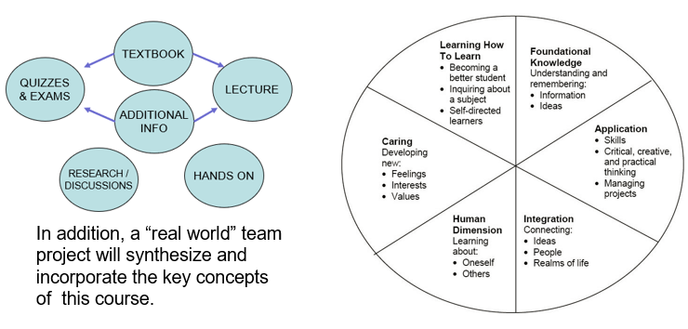

I hope students will: master the material and its relationship to other courses; understand the personal and social aspects of the subject; and desire to learn MORE about cyber security.

**Course Prerequisites**

* I expect college level work. All submissions and presentations should be proofed and professional. Submissions should be properly formatted.
* CMPT-306 and 307 – We’ll cover some of what you learned in Data Communications and Internetworking, but reviewing and refreshing that material would be a bonus.
* Number Systems – You needed to know binary and hex and ASCII for both Data Communications and Internetworking. You’re going to need that again. If you are not 100% comfortable with these, there are many online tools to help you.

**Required Text and Resources**

* **Elementary Information Security by Richard E. Smith (3nd edition, 2019, Jones & Bartlett).**
* The course uses a required online cloud-based lab environment. Ensure you get the PREMIER access offering from the publisher (NOT the “advantage” access, which does NOT include the labs). Be careful if you order a used book package – it must come with a valid access code! If you get an e-version, make sure you receive a card with the software access code
  + ISBN for print book and premier/lab access : 9781284214741
  + ISBN for ebook and premier/lab access : 9781284320930
* NOTE: you do not need to specify a course id when you access the J&B software.
* Non-textbook material will also be presented on lecture slides. I strongly advise students to take notes!
* **Please bring personal laptops for the hands-on portion of this class.**
* Please refer to my website for links to articles, videos, and other resources   
   https://aptokash.github.io/Home/
* I also strongly recommend the following book and websites:
  + “Cybersecurity Blue Team Toolkit” by Nadean Tanner
  + “CompTIA Secuirty+Exam Guide” by WM> Arthur Conklin and Gregory White
  + The “Center for Internet Security” website
  + *ThreatPost Today* daily bulletins

**Weekly Modules, Workload and Expectations**

Each week I will post in the ILearn resources the current module’s resources. A key file is the “READ ME FIRST” file which details due dates, course progress, module contents, student requirements, and other important information. This should be consulted regularly.

Also posted will be: weekly quizzes, assignments, labs and/or projects; PPT slides with supplementary (non-textbook) information; and additional materials or videos.

Assignment, lab and project files must be submitted into ILearn. Documents must follow a standard naming convention and have proper page headers. Refer to the file “Submission Guidelines” in the Ilearn Resources section. Unless otherwise specified, submissions should be in PDF format.

**Good note taking** is a key skill for active learning, and reading the textbook is a requirement for the course. For these reasons I will release in Ilearn only the Power Point slides of material that is not from our textbook. (There are copyright restrictions, as well).

There is “Peer Assistance” forum to post issues/questions on any course work.

No course material – PPT’s, quizzes, videos, etc.– may be reproduced or distributed without my consent.

**The Difference Between the Grades 90% and 100%**

An “A” is awarded to submissions that are “excellent”. This generally means that the submission took extra time in the research and presentation. If a student answers the questions or follows the instructions correctly they will be graded with a 90% A. However, to be truly excellent they will provide more than just the briefest of answers. They may do some extra research, especially tying in other threads of material previously learned. They may add screen shots or try additional commands.

Below are two sample submissions for the same assignment. While they both answer the question, one is clearly more “excellent” than the other.

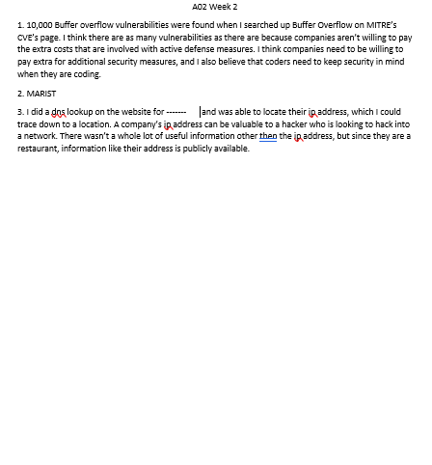 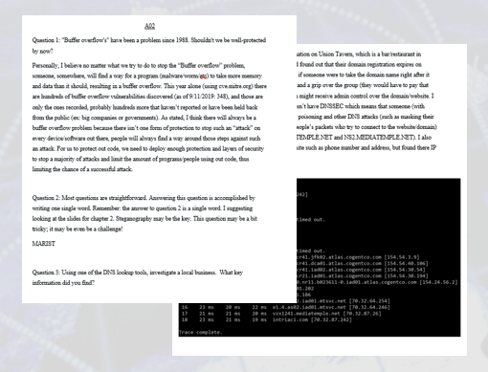

**Class Attendance, and Remote Learning/Zoom Classes**

Students are expected to attend all classes and to actively participate in classroom activities and discussions. (Class attendance helps students learn more, and also prepares you for the workplace where you will also be expected to ‘show up’.) Ensure that you have a study partner to provide class notes in the event of any absences.

Cell phones/laptops/tablets may only be used for note taking and doing labs. I expect all students to be respectful.

In the event of a campus wide ‘pause’ or inclement weather, class periods will be remote via Zoom. When attending via Zoom, students are required to keep their video feeds live, and will be responsible for any class work covered during the normal class time.

During classes, I randomly ask students questions. I hope this breaks up the monotony of a lecture and helps keep students participating. If you choose to not be ‘picked’, for whatever reason, just email stating your preference.

**Additional Activities – Labs, Presentations, and Case Study**

* Ten labs - based on the bundled software - will be assigned almost weekly, with students working solo. Students are expected to complete the lab and submit a lab report. Again, as this is a 4-credit course that meets only twice per week, students are expected to spend additional non-class time working on labs.
* Each student will be assigned a 5-minute presentation to the class, based on a section of the textbook or some other material.
* In the second half of the semester, students will complete a comprehensive case study of a real data breach or cybersecurity hack. This exercise will involve student research as well as a synthesis of core cybersecurity concepts.

**Tentative Semester Schedule**

Below is the tentative semester schedule, and will change through the semester. The updated schedule is maintained in the course READ ME FIRST file, and displayed at the start of each class.

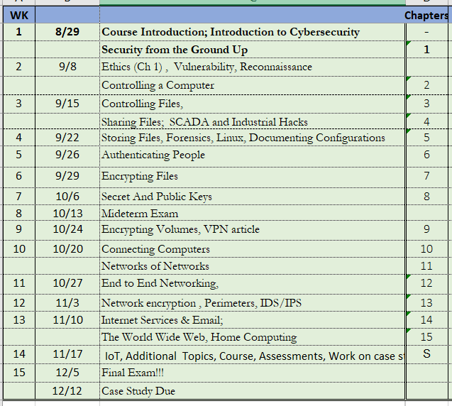

The below chart details the course structure.

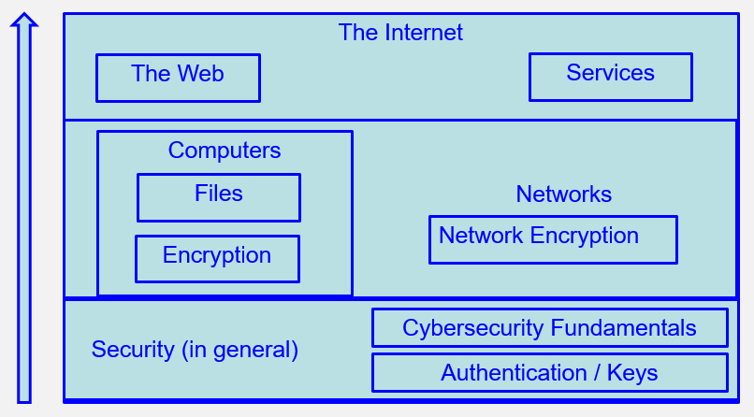

**Computer Science Department Goals**

*“Today, companies expect not only technical hard skills, but also so-called professional skills [which] include communication, project management, conflict management, diversity management and teamwork.”* – Marc-Oliver Pahl

1. Prepare students for employment in a technology field or for graduate study in a technology field.
2. Provide students with both theoretical knowledge and skills-based proficiencies in the five core technology competencies: programming, hardware, data communications, data management, and systems/software analysis and design.
3. Provide students with fundamental knowledge of business administration and management so that graduates will be able to work effectively within businesses and other organizations.
4. Develop interpersonal skills for working effectively on teams.
5. Develop effective written and oral communication skills.

**Course Objectives**[1]

1. Understand computer security, white- and black-hat hacking, Google hacking, vulnerabilities, etc. [1,2]
2. Understand computer and file access controls and demonstrate how to set controls on the Windows operating system. [1,2]
3. Understand both symmetric and asymmetric encryption techniques. [1,2]
4. Understand computer networking, including both the security implications and business management controls. [1,2,3]
5. Understand the operation and security requirements for computer applications and the Internet. [1,2,3]
6. Understand cybersecurity’s legal requirements and the ethical dimensions. [3]
7. Perform simulated computer sessions using state-of-the art security tools. [1,2,3]
8. Research a real-world security breach; develop and present a comprehensive security report. [1,2,3,4,5]
9. Work in teams on lab assignments and class presentations. [1,2,3,4,5]
10. Submit professional module and lab assignments. [5]

Note: **A detailed list of ‘core competencies’ is provided for each module.** This list details expected acquired knowledge topics and demonstratable skills.

Note: Due to the pandemic we’re often forced to incorporate online instruction and online team-work. While this has some drawbacks, it also prepares students for the modern workforce, which more and more include remote employees and online team projects.

**Course Evaluation**

Students are assessed through exams, self-assessment quizzes, assignments, presentations and projects. Written projects and presentations will be used to assess their interpersonal, written and oral skills.

10% Lab assignments

5% Class presentation

15% Weekly self-assessment quizzes on textbook chapters

40% Exams (midterm, second and final)

15% Weekly assignments, in class quizzes, etc.

10% Comprehensive team case study

5% Class Attendance & Participation

The aggregate grading policy for midterm and final grades will be the standard Marist grading system, and will be displayed in the iLearn gradebook.

**All assignments are to be submitted by the due date specified.** Make-up opportunities for assignments, assessments, and exams are provided only for verifiable extenuating circumstances cleared through CAAS. Acceptable excuses for late submission of assignments include situations covered in the Student-Athlete Handbook, illness, and serious extenuating circumstances (e.g., death in the family, serious illness).

NOTE: I generally do not provide extra-credit or make-up assignments.

The aggregate grading policy for midterm and final grades will be ta modification of the Marist grading system, and will be displayed in the iLearn gradebook. Please continuously monitor your iLearn grade and contact me for any questions. Do not wait until final weeks to bring up any issues.

|  |  |  |
| --- | --- | --- |
|  | 94 **A** | 90 **A-** |
| 87 **B+** | 83 **B** | 80 **B-** |
| 77 **C+** | 73 **C** | 70 **C-** |
| 65 **D+** | 60 **D** |  |

**Learning Disabilities**

Students have all types of learning disabilities. It is your responsibility to notify the professor in the beginning of the semester in order to make sure you are successful within this course! If you’re unsure whether you have a learning disability, make sure you see Special Services within Donnelly as soon as you suspect your disability!

For students with accommodations, it is your responsibility to make testing arrangements for any exams or practicum with the Office of Accommodations and Accessibility, and that office generally needs advanced notice of at least two business days.

**Academic Honesty**

Faculty will uphold and enforce the general policies of this institution on academic honesty and plagiarism. All examinations, assignments, and projects are subject to the standards of academic honesty as described in the Student Handbook and/or other related publications.

Neither plagiarism not cheating will be tolerated. If you are suspected of cheating, you will be asked to explain the work. If you cannot you will be ejected from the course with a failing grade, in addition to any other forms of recourse available to the instructor as specified by the Student Handbook.

You are encouraged to discuss the course material, concepts, and lessons with other students in the class. However, your labs, exams and discussions must be your own work. If you are caught copying or otherwise submitting material that is not solely your work, you will fail the course and a letter will be sent to the department chair.

Please consult the ACM code of ethics. See [www.acm.org/constitution/code.html](http://www.acm.org/constitution/code.html).

**Diversity and Inclusion**

The college's academic mission is immeasurably enriched by students with diverse experiences. Our finest efforts as intellectual beings heavily rely on the exchange of ideas. Interactions in our classrooms among persons and groups with diverse backgrounds, ideologies, and experiences facilitate these efforts by allowing us all to be more reflective about the varied historical and social contexts in which we work and learn.

In this course, we will challenge each other’s thinking while working collaboratively to ensure that the classroom is a space of safety and bravery. Our classroom offers an environment where individuals of varying opinions, experiences, and backgrounds can freely learn without fear of being silenced.

Aspects of diversity include, but are not limited to, race, ethnicity, color, nationality, sex, gender, gender identity, gender expression, class, sexual orientation, religion, age, ability, and veteran status. Students who would like to be identified in a manner other than what is indicated on the course roster can contact me privately to indicate name, pronoun and any other preferences they may have.

**Title IX Information**

Marist College is committed to providing a safe learning environment for all students. If you or someone you know has experienced sexual harassment, including sexual assault, dating or domestic violence, or stalking, support is available. Please contact the Title IX Office at titleix@marist.edu or (845) 575 - 3799 or visit www.marist.edu/title-ix to file a report. Please be aware that faculty and staff are required to disclose incidents of sexual harassment or other potential violations of the Marist College Discrimination, Harassment, and Sexual Misconduct Policy to the Title IX Office. To speak to a confidential resource who does not have this reporting responsibility, contact Counseling Services at (845) 575 – 3314, Health Services at (845) 575 – 3270, or Campus Ministry at (845) 575 – 3000 (x2275).

**How to Get an “A” in this Course**

1. Attend classes.
2. If something is unclear ASK for a better/different explanation.
3. Be an active student. Take notes, listen, speak, ask questions.

Refer to: https://post.edu/blog/preventing-information-overload-note-taking-tips-students/

1. Do a quick review of chapters BEFORE the class to identify confusing sections.
2. Read the chapter and review each section’s TEST YOUR UNDERSTANDING questions.
3. Do all assignments and submit them on time with proper formatting and citations. Begin assignments early in case you have questions.
4. Do not copy assignments from other students, the Internet or any other source.
5. Take your time with SELF ASSESSMENTS. Review material BEFORE taking the quiz.
6. Study for the exams. Use the Core Competencies as a study guide.
7. Work with other students and take advantage of office hours.
8. Monitor your grades weekly.
9. Use a flashcard application (ex: Quizlet) to help you study. Use the publisher’s flashcards included with premier access.
10. Participate fully in team projects!
11. Use the Marist Writing Center and the other resources.
12. If you have any questions, confusion or issue, address them immediately. Do not wait until the end of the semester to do so.

**Changes to This Syllabus**

08/29/2022 Initial course syllabus for Fall 2022

09/08/2022 Added a second exam. Combined exams are still worth 40% of grade, and the   
 change either didn’t affect the grade or increased student scores

*End of Document*

1. The reference number in brackets [ ] indicates the department goal that is being met with the fulfillment of the objective.